**36)**

**Aim:** To Design Non Deterministic Finite Automata using simulator to accept the string the start with a and end with b over set {a,b} and check W= abaab is accepted or not.

**Diagram:**

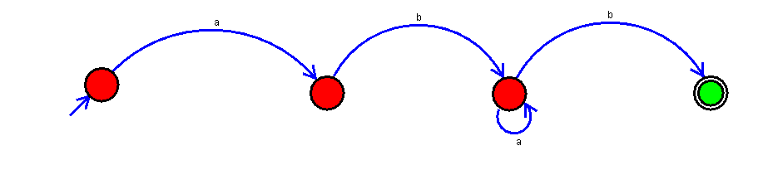

**Result:**

Thus, successfully executed Non Deterministic Finite Automata using simulator to accept the string the start with a and end with b over set {a,b} and check W= abaab is accepted or not.